Information VisualizationFinal task

システム情報学研究科

システム科学専攻

学籍番号： 194x024x

氏名： 伍糸雨

1. Functions:1-1. Users can change the shading models with original model (no reflection),  
lambertian reflection model, phong reflection model, blinn-phong reflection model  
and cook-torrance reflection model by selecting in the drop-down list.  
1-2. Users can add/delete slice planes and change the height of these slice planes by  
dragging the slider bar.  
1-3. Users can change the color of these models by selecting colors in the controller.  
1-4. Users can change the isovalue of these models by dragging the slider bar.  
**2. How to use:**  
We can use the following functions as below:

2-1.Change isovalue.  
We can change isovalue from 0 to 255.

2-2.Change color.  
We can change color of lobster by changing the value of R,G,B from 0 to 255.

2-3.Shading model.  
(1). noraml model: the extracted isosurfaces from the lobster data without any reflection or shading. The color can’t be changed. 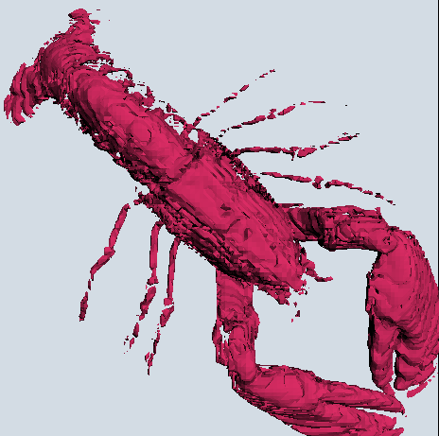

(2). Lambertian reflection model: the implementation of lambertian reflection based on the original model with vertices interpolated. The color can be changed. 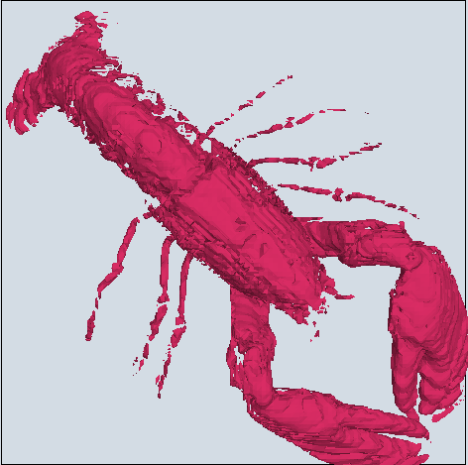

(3). Phong reflection model: the implementation of phong reflection based on the original model with vertices interpolated. The color can be changed. 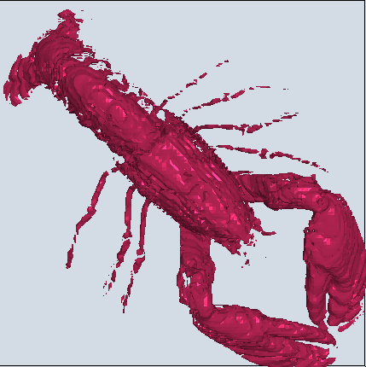

(4). Blinn-phong reflection model: the implementation of blinn-phong reflection based on the original model with vertices interpolated. The color can be changed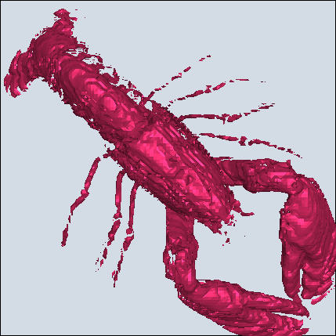

2-4.Reset.  
You can click “Reset” button at any time, and the input will be reset immediately